OO Programming Fundamentals

Practical Class 10 – Week 24th November 2014

- Create a Practical Week folder in your Java folder on your G drive

G:\Java\Practical Week 10

- Save all the following exercises into the Practical 10 folder

Exercise 1

The following program creates an integer array f[ ] in main() and initialises it with 5 values 2,3, 4, 5 and 6.

main() uses a method call to call up the method printArray() and passes in the array f[ ] as a parameter.

printArray() receives the array as a parameter.

It then uses a for loop to print the content of the array to the screen.
import java.util.Scanner;
public class ex10a
{
public static void main(String args[])
{
int f[] = {2, 3, 4, 5, 6};
printArray(f); // Call up procedure printArray() and pass in array f[]
System.out.println();
}

public static void printArray(int [] ar)
{
int i;
for( i = 0; i < ar.length; i = i + 1)
{
System.out.println(ar[i]);
}
}
}

Save as ex10a.java
Sample Output:
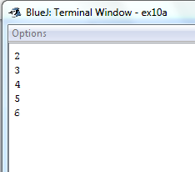

Exercise 2

Rewrite Exercise 1 to ask the user to enter the 5 values for the array f[ ] in main().
Save as ex10b.java
Sample Output
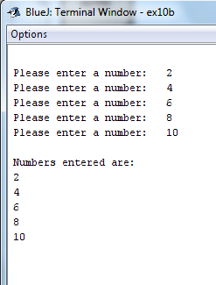

Exercise 3
Rewrite Exercise 2
This program will have 3 methods:
- main()
- acceptValues()
- printArray()
- main() will create the array f[ ] and will then call up acceptValues() and pass the array f[ ] in as a parameter. It will then call up printArray() and pass the array in as a parameter.
- A new method called acceptValues() will receive the array as a parameter. It will then ask the user to enter the 5 integer values into the array.
- printArray() will receive the array as a parameter and will print the contents of the array to the screen
Save as ex10c.java

Sample Output:
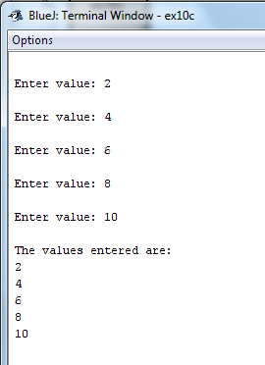
NOTE***
With arrays, it is important to note that when you pass an array as a parameter into a method, you are not passing a copy of the contents of the array - as you are with normal integer, double, character variables.
In the case of arrays, the value sent as a parameter is NOT a copy of each array element but, instead, a copy of the array reference - the location of the array is sent to the receiving method, not the value of the contents of the array.
In this program, the 3 methods will have access to the same array f[ ] .
In main() the array is declared as f[ ].
acceptValues() will receive the array as a parameter using a different array name
printArray() will receive the array as a parameter using another array name
But once the array is passed as a parameter, and both acceptValues() and printArray() can access and modify the original array f[ ].

Exercise 4
The following program accepts 3 student ages from the user and uses a method to calculate the average age of the 3 students
- Within main() an integer array of 3 elements called ages[ ] is created.
- A for loop is used to fill the array with 3 student ages from the user.
- A method call is then used to call up a method called averageAge() and the array ages[ ] is sent in to averageAge() as a parameter.
- averageAge() receives the array as a parameter and can now access and modify the array ages[ ]
- It then uses a for loop to calculate a running total of all the values in the array (i.e. add all the values in the array)
- The running total value is then used to calculate the average age - total / agesIn.length
- The average age is then printed to the screen
Enter in Bluej and compile and run.
import java.util.*;
public class ex10d
{
public static void main(String args[])
{
Scanner sc = new Scanner(System.in);
int[] ages = new int[3];
int i;
for( i = 0; i < ages.length; i = i + 1)
{

System.out.println("Please enter student age:");
ages[i] = sc.nextInt();
}
averageAge(ages); // Method Call
}

// Method header for averageAge()
public static void averageAge(int [] agesIn)
{
double total=0, average;
for(int j = 0; j <agesIn.length; j = j + 1)
{
total = total + agesIn[j];
}
average = total / agesIn.length;
System.out.println("The average age of students is: " + average);
}
}
Save as ex10d.java
Sample Output
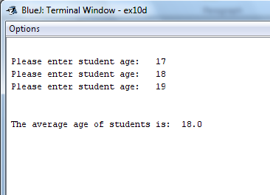

Exercise 5
Rewrite Exercise 4
This program will have 3 methods:
- main()
- acceptAges()
- averageAge()

- main() will create an integer array of 3 elements called ages[ ]. It will then call up acceptAges() and pass in the array as a parameter. Next it will call up averageAve() and pass in the array as a parameter.
- A new method called acceptAges() will receive the array as a parameter, and ask the user to enter the 3 integer values and store these 3 values into the array.
- averageAge() must receive the array as a parameter, calculate the average age of the students using the array and print the average age of the students to the screen.
Save as ex10e.java
Sample Output:
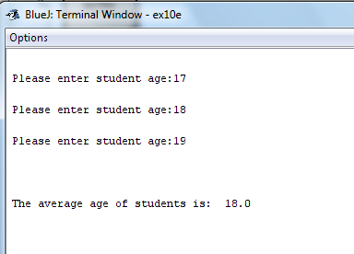

Exercise 6
The following program uses 3 methods and demonstrated how to return arrays:
- main()
- enterTemps()
- displayTemps()

NOTE**
- A method can return an array as well as receive an array as a parameter.
- In this program we do not send an array to enterTemps() but, instead, create an array within enterTemps() and fill this array with values. The array can then be returned from the enterTemps() to main() .
- We are not passing in any parameters to enterTemps(); However, enterTemps() now returns an array. We need to store the value being returned.
- We use the returned value to set the value of the original temperature[] array that was declared in main(). We don't have to allocate a size to temperature[] because it takes the size from the returned array parameter.
- In main() displayTemps() is then called up and the array temperature[] is passed in as a parameter.
- displayTemps() receives the array as a parameter, and displays the contents of the array to the screen.

Enter in Bluej and compile and run:.

import java.util.*;
public class ex10f
{
public static void main(String[] args)
{
double [] temperature;
temperature = enterTemps();
displayTemps(temperature);

}

public static double[] enterTemps()
{
Scanner sc = new Scanner(System.in);
double [] temperatureOut = new double [7];
for(int i = 0; i < temperatureOut.length; i = i + 1)
{
System.out.print("Enter temperature for day: ");
temperatureOut[i] = sc.nextDouble();
System.out.println();
}
return temperatureOut;
}

public static void displayTemps(double [] printTemp)
{
Scanner sc = new Scanner(System.in);
System.out.println("Output of the array temperature[]: ");
for(int i = 0; i < printTemp.length ; i = i + 1)
{
System.out.println(printTemp[i]);
}
}
}

Save as ex10f.java
Sample Output:
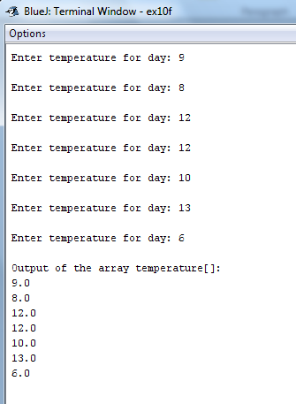

Exercise 7:

Write a program to do the following:
- In main(), create an array called numbers[ ] that will store 10 integer values
- Pass this array as a parameter into a method lessThan().
- lessThan() must receive the array as a parameter and must read in 10 integers values from the user
- lessThan() must go through the array and print to the screen any value which is less than 5.
Save file as ex10g.java
Sample Output

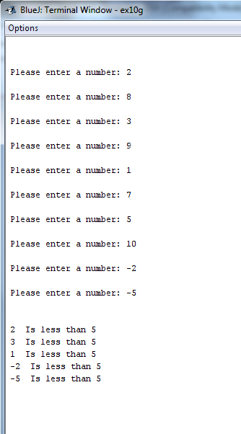

Completing this weeks’ Practical:
- When you submit work, you will send it in zip file format.
- To create a zip file of your practical work:
  - In Windows Explorer, right click on the Practical Week 10 folder that contains your work.
  - When the context menu appears, choose the Send to option, followed by the Compressed (zipped) folder.
  - This will create a new file called Practical Week 10.zip in your current folder
- Note: If you are using your own laptop, you can choose to install very good (and free) compression software called 7zip. Just search for it in Google and download it.

*** It is this zipped file that you will upload into Moodle.***

